**Step 1: Setup Git Repository**

**Description:**  
Created a new folder git-branch-lab and initialized it as a Git repository with an initial commit.

**Commands Used:**

git --version

cd /c/Users/Dell/GitDemo

cd /c/Users/Dell/GitDemo

git checkout master

p4merge

git checkout -b GitWork

echo "<greeting>Hello from GitWork branch</greeting>" > hello.xml

**Screenshot(s):**  
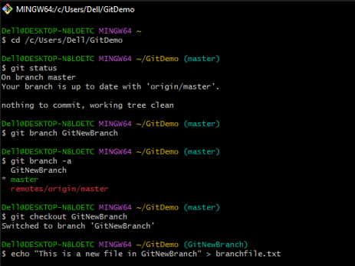

**Step 2: Create a New Branch**

**Description:**  
Created a new branch named GitNewBranch and switched to it.

**Commands Used:**

echo "<message>Updated in GitWork branch</message>" >> hello.xml

git add hello.xml

git commit -m "Added and updated hello.xml in GitWork branch"

**Screenshot(s):**  
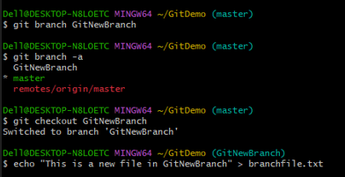

**Step 3: Add Files in the Branch**

**Description:**  
Created a file named branchfile.txt in GitNewBranch, staged it, and committed it.

**Commands Used:**

git checkout master

echo "<greeting>Hello from master branch</greeting>" > hello.xml

git add hello.xml

p4merge

**Screenshot(s):**

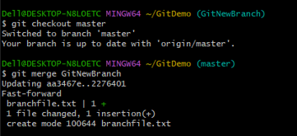

**Step 4: Merge Branch into Master**

**Description:**  
Switched to master branch, compared changes, merged the branch, and viewed the merge history.

**Commands Used:**

git checkout master

git log --oneline --graph --decorate --all

git diff master GitWork

git config --global merge.tool p4merge

**Screenshot(s):**

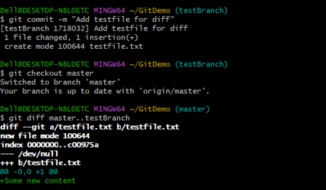

**Step 5: Delete the Branch**

**Description:**  
Deleted GitNewBranch after merging and verified the repository status.

**Commands Used:**

git config --global mergetool.p4merge.path "C:/Program Files/Perforce/p4merge.exe"

p4merge

**Screenshot(s):**

